Little Rock REALTORS® Association provides its membership the opportunity to enhance REALTOR® performance through education, technology and integrity.
Little Rock REALTORS® Association
April 2023
CALENDAR OF EVENTS

April 4th- YPN at Cantina Laredo from 5 to 7 PM
April 9th- Easter
April 13th- April General Meeting at Pleasant Valley Country Club from 12-1:30
April 17th- LAC and BOD Meetings
April 26th- Administrative Professionals Day

APRIL GENERAL MEETING
Join us on April 13th from noon to 1:30 at Next Level Events for our first General Meeting of the year. Our speaker will be LRPD Police Chief Heath Helton. Chief Helton will be discussing current crime numbers here in LR, discuss his plan of action for our city moving forward and end with a Q&A from the audience. New members will also be inducted at this meeting. Lunch is provided and doors open at 11:30 AM (you are encouraged to arrive early). Tickets may be purchased through your membership portal at www.LRRA.com. Tickets for members are $25/each and tickets for guests are $35/each. Our April General Meeting is sponsored by Choice Home Warranty Company.
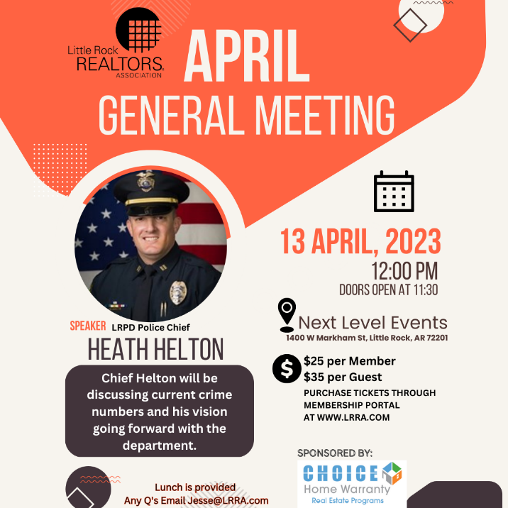

AFFILIATE SPONSORSHIP OPPORTUNITIES
LRRA is looking for sponsors for the 2023 year. Please contact Libby for sponsorship opportunities. We try not to have sponsors from the same industry, but we cannot guarantee it won’t happen...i.e. 2 mortgage companies, 2 inspectors, etc. Please email Libby@LRRA.com and cc Jesse@LRRA.com to let us know you want to sponsor and we will let you know if the sponsorship is open.
We have general Meetings, Orientations, Lunch and Learns, REALTOR® Awards of Distinction, Broker meeting, and many more opportunities to sponsor in 2023. Thank you for all you do to support the Little Rock REALTORS® Association and our members!
To our LRRA members: Please take note of the Affiliate members who sponsor our events. They are investing in you and we hope you will take note and invest in them in return by giving them your business.

YPN EVENTS BEGINNING AGAIN!
YPN (YOUR Professional Network) will now be the FIRST Tuesday of each month, except for January and July of 2023. The next YPN will be April 4th at Cantina Laredo from 5 to 7 PM!
Thank you to our April sponsors: Mortgage Financial Services, Cornerstone Restoration and Primary Residential Mortgage. We are still looking for sponsors for YPN for 2023!!!. Any Affiliate looking to sponsor please contact our YPN Chair Meg France by emailing Meg@jonunderhill.com

2023 ORIENTATION
Next Orientation
If you have missed your scheduled Orientation date or missed being inducted in the past year, please notify Jessica@LRRA.com so you can complete the process and not have to start the process all over.
Please note that you have two opportunities to attend an orientation from the time that you sign up for membership. If you miss those two opportunities you will be placed on inactive status and your CARMLS access will be inactivated until you have completed orientation. You will be notified by email when you become eligible to attend New Member Orientation. Our next Orientation will be in person, at our office on March 9th.

NEW MEMBERS
Brokers, we work very, very hard to get your agents onboarded as fast as we can, however, this time of year takes longer, because of the high instances of transfers, new members and new offices at this time. Please make sure to let your new agents know that joining, transferring, or changing information takes longer than normal at this time. Please make sure they know it may take up to 24 hours to get all the information needed and uploaded before they can expect to have access to the MLS or forms.

TRANSFERS
If you are planning on transferring, please remember that it may take a few days longer than usual because the AREC is very busy at this time. If transferring offices, please submit the LRRA office transfer form and $35 to the Little Rock REALTORS® Association once you’ve transferred with the AREC. Please remember anything else may take longer than usual and everyone should expect it to take at least 24 hours to get you onboarded.

Legislative Affairs
CAW Rate Increase
The Central Arkansas Water (CAW) Board of Commissioners in January approved a rate increase that will more than double the typical household water bill by 2032. Unless the Board’s decision is overturned, the 10-year increase will begin July 1. Little Rock Director Lance Hines proposed a resolution opposing the rate increase, but asked earlier this month that a vote be delayed until April. In order to overturn the increase, both the Little Rock City Board and the North Little Rock City Council would have to oppose. There has not been a similar opposition measure filed in North Little Rock.

The rate will go from half-a-cent per gallon, to a full cent per gallon in 2023. The average household bill today is around $15.80. That is forecast to be $32.51 in 2023. A $4.25 fixed infrastructure fee will also be implemented in 2032. CAW says it expects the increase to cover $685 million in improvements over the next 10 years. Meanwhile, CAW recently announced a program to help eligible Little Rock residents receive free water and wastewater service for up to a year. The program is through federal funding, and CAW will accept applications through September 30.

Part of the improvements approved by the CAW Board include a reservoir management system to control an invasive species of plant called Hydrilla.

Short-Term Rental Ordinances
The City of Little Rock’s proposed short-term rental ordinance has been delayed again, pending the outcome of SB197, being considered by the Arkansas General Assembly. The statewide legislation would ban most local ordinances regulating short-term rental properties. During earlier discussions, some directors expressed concerns over issues like parking, on-call maintenance and inspections. Meanwhile, North Little Rock is considering a short-term rental ordinance that would ban the properties is certain areas.

Hillcrest Overlay Proposal
The Hillcrest Residents Association (HRA) has developed six proposed changes to the Design Overlay District.
The City is held an informational meeting March 23, and the public hearing is scheduled before the Planning Commission April 13. There is a form on the City’s website to submit written comments.
https://www.littlerock.gov/business/planning-and-development/hillcrest-dod/

LRRA EDUCATION ROOM RENTAL
LRRA rents its Education Room and Board Room out to interested groups in need of a classroom or lecture space. The Education Room is perfect for meeting space and seats up to 55. Our Education Room comes equipped with a large white board, a projector, overhead projector, podium, screen, 55 “television and Internet connections for all your connection needs. Our building is also equipped with Wi-Fi. Please call Jesse at 225-1987 or email at jesse@lrra.com for competitive rental rates.

Financial Wellness Webinars
The NAR is offering Financial Wellness Webinars which are designed to help REALTORS® understand financial topics on a deeper level. No matter the career stage or level of financial planning, these webinars are helpful and informative to all members. Go to their website to learn more and get signed up.
CODE OF ETHICS vs. CE
The Code of Ethics….is a course each NAR-ARA-LRRA member takes upon joining the association and every three years after, for the duration of your membership. The Code of Ethics is what distinguishes our members from being just a licensee. Passing the Code of Ethics is what distinguishes a REALTOR® from a real estate agent. In order to reaffirm your commitment to being a REALTOR® you must retake the course every three years. It is on line and free. The current cycle ends December 31st, 2024.
Your Code of Ethics is not necessarily a continuing education class. It can be, but is not CE unless clearly stated by the instructor.
Each time you take Code of Ethics courses, either on line or through a licensed instructor, it is the agent’s responsibility to send a copy to their local board for coding into the NRDS system.
Code of Ethics does not go to the Arkansas Real Estate Commission…..it goes to your local board for entry into the NRDS database.
CE is what is required by the Arkansas Real Estate Commission for you to maintain a license to practice real estate in Arkansas.

NAR CODE OF ETHICS REQUIREMENT
We want to make you aware of a new NAR rule concerning Code of Ethics. Please make sure your agents are aware of this new NAR requirement.
If your agent believes he/she has taken it then they will need to provide us with a copy of their certificate showing the course included NAR required Code of Ethics.
We do not necessarily get notice that the agent completed the requirement when the educator turns the course list into the Commission. It is up to each agent to provide LRRA with a copy of their certificate to show they have completed the 2.5 required hours.
Noncompliance will force us to inactivate your membership. We do not want to do that! Please make sure you take the course at least 1 time every 3 years.

NEED YOUR NRDS NUMBER?
Do you need your NRDS number to pay dues, make a reservation, log on to REALTOR®.org?
If you joined the REALTORS® association through LRRA, your NRDS number will begin with 1280.
If you don’t have it here are some simple ways to find it:
- Look at the white address label on the cover of YOUR REALTOR® magazine . Your NRDS number will be there.
- Go to our website at www.LRRA.com and click on the box in the top left-hand corner of our homepage that says ‘Locate NRDS# Here’
- Once you have it, write it on the back of your pocket card for safe keeping.

REALTOR® TEAM STORE- LRRA DISCOUNT FOR MEMBERS ONLY
Want to order REALTOR® merchandise and receive a discount?
Well now you can! Go to the address listed below!
LRRArealtorteamstore.com
Buy REALTOR® logo merchandise and save 5% using your Little Rock REALTORS® Association discount code.
Enter LRRA under the area marked “Discount Coupon” during checkout at step 2 of 4.

WELCOME TO LRRA OUR NEWEST REALTOR MEMBERS
David Carter (Eagle Rock Realty Little Rock)
Thomas Priest (Eagle Rock Realty Little Rock)
Tiffany Lindsey (The Charlotte John Co)
Rikicia Mayes (Rackley Realty Inc.)
Allen Evans (RPM Group)
Kenneth Long (Engel & Volkers)
Caimetrez Lane (Plush Home Company)
Hudson Brown (Coldwell Banker RPM Group - WLR)
Lance Cook (Cook and Company)
Jeremy Kessler (Crye-Leike Realtors Financial)
Brandon Brown (Keller Williams)
Uneeda Blackwell (Keller Williams)
Angela Parnell (New Door-A Real Estate)

NEW OFFICES
Adkins & Associates Real Estate (Dennis Adkins)
Cook and Company (Scott Cook)

LRRA Mission Statement: Little Rock REALTORS® Association provides its membership the opportunity to enhance REALTOR® performance through education, technology and integrity.
LRRA Vision Statement: Little Rock REALTORS® Association strives to serve as a voice for local REALTORS®, encourage a high level of ethics, education and professionalism among its members and to advocate on behalf of the profession.
LRRA Core Values: Education, Professionalism, Support of Members, Value to the Membership, Integrity, Property Rights, Voice to lobby and promote, Serve and Support our members and community, Advocacy and Ethics.

LITTLE ROCK REALTORS® ASSOCIATION, INC.

2023 OFFICERS AND DIRECTORS

OFFICERS

President
-

Fletcher Hanson
-

Moses Tucker Partners

President Elect
-
Matty Ross
-
-The Charlotte John Company

Treasurer
-

Jon Kennon
-
iRealty Arkansas

Secretary
-
Mitsy Tharp
-
Signature Properties

Past President
-
April Findlay
-
-The Charlotte John Company

DIRECTORS

Ross McCain – The McCain Company
-

John Selva
-
Engel & Volkers
-

Kaye Chambers
-
-Keller Williams Realty Little Rock

Jennif
er Kronenberger
-
JK Real Estate

Patrick McKay
-
The Property Group

Stacy Hamilton
-
Coldwell Banker RPM Group - WLR

Conley Jones
-
-The Janet Jones Company

-

Whitney McLellan

-McLellan & Associates Real Estate

Kathy Patton

-Cry-Leike REALTORS – Kanis Branch

