Little Rock REALTORS® Association provides its membership the opportunity to enhance REALTOR® performance through education, technology and integrity.
Little Rock REALTORS
March 2024
CALENDAR OF EVENTS

March 4th – LAC & BOD Meetings
March 5th- YPN @ A Loft West from 5 to 7 PM
March 7th – New Member Orientation @ LRRA from 9 AM to Noon
March 28th- Retirement Party for Libby at County Club of LR from 5 to 7 PM

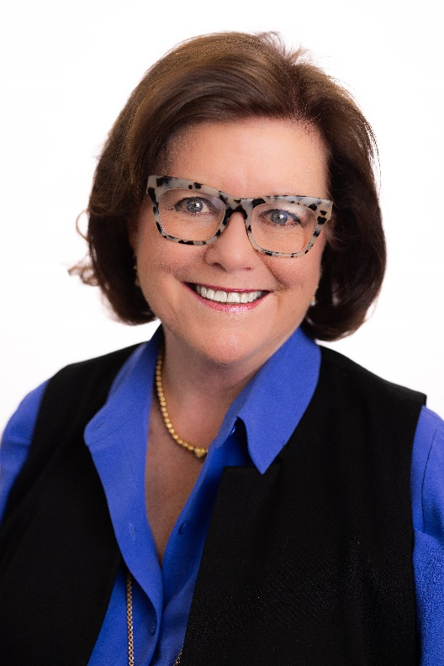
A farewell from Association Executive Libby Sheard
Dear Friends,

Well, it’s time……The time has come for me to hand over the reigns of the association to someone new. Stacy Hamilton, past president, and long-time volunteer for LRRA will be taking the position of Executive Director of LRRA and you could not be in better hands. I’ve said it before and I’ll say it again, this is the best job in the world, and I have been lucky enough to have it for over 20 years now.
You all are part of the single most important avenue to personal wealth and personal achievement for the consumer. I have been proud to be a part of this process. I have always remembered and believed the saying “Beneath all is the land.” I am proud to be a part of an organization that promotes property rights, home ownership and advocacy for these fundamental rights.
I have had the privilege to work with some of the most incredible and amazing people in Arkansas and beyond! In the past 20 years we have managed to bring to you all some amazing speakers, teachers, trainers, and representatives of our industry. That was my goal, to open the Realtor world to my members. Bring these leaders of our industry to Little Rock and to our membership. We have had numerous National Association of Realtor presidents, CEO’s, Congressmen, Senators, appraisers, and inspectors. We have had authors, leaders in the FBI, State Police and local police talk to us about our local, state and national issues concerning real estate fraud, mortgage lending and title fraud. We have heard from those involved with safety, motivation, quality of health, environmental issues, diversity, and education. In a word, I wanted you all to have every single possible benefit you could have when it comes to knowing your community. I wanted you all to be knowledgeable about our community. I wanted to educate and inspire our membership. I hope we have done so.
One of the things I love the most about this industry is the relationships between our members. You all are competitors. BUT, you work hard and then you play hard together. One minute you are competing for your clients and the next minute you are sitting in a congressman’s office and talking about law that effect real estate, our members, and the community we serve. We serve together for the benefit of our local community. I love the soul of real estate. I hope I have provided you all with the tools you need to succeed, friendships that will last a lifetime, and the ability to effectively do your job in a community you love.
You all have provided me with a lifetime of happy memories. Thank you all for the opportunity.

Libby
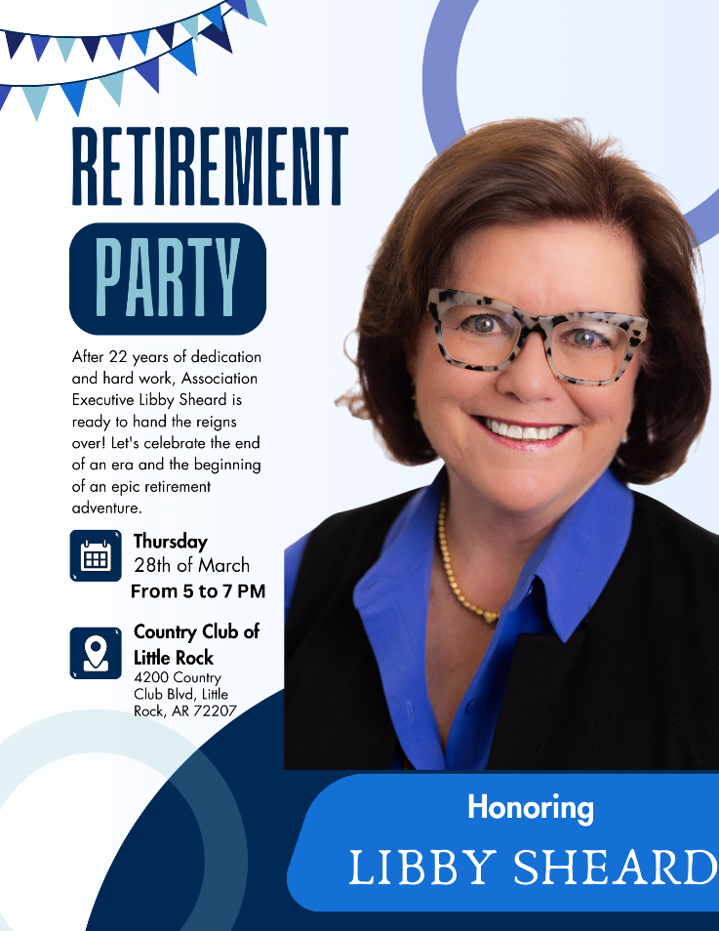
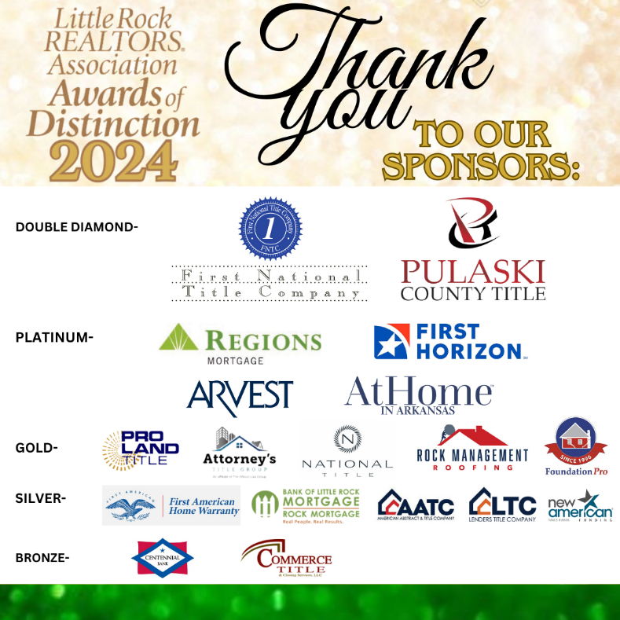

April General Meeting
Our April General Meeting will be on April 25th from 9 to 11 AM at Next Level Events (1400 W Markham St). The speaker for the meeting will be Tim Grooms. Tim will be giving a legal update regarding NAR. During this meeting we will also induct new members and introduce ARA’s new CEO, Stephanie White and ARA President Jennifer Welch. Tickets for members are $25/each and tickets for guests are $35/each; a continental breakfast will be served.

YPN EVENTS BEGINNING AGAIN!

YPN (Young Professionals Network) will now be the FIRST Tuesday of each month, except for January and July of 2024. The next YPN will be March 5th at A Loft West from 5 to 7 PM! We take cash or credit/debit card at the door: $10 for everyone. Any Affiliate looking to sponsor please email jesse@LRRA.com

2024 ORIENTATION
Next Orientation
If you have missed your scheduled Orientation date or missed being inducted in the past year, please notify Elle@LRRA.com so you can complete the process and not have to start the process all over.
Please note that you have two opportunities to attend an orientation from the time that you sign up for membership. If you miss those two opportunities you will be placed on inactive status and your CARMLS access will be inactivated until you have completed orientation. You will be notified by email when you become eligible to attend New Member Orientation. Our next Orientation will be in person, at our office on March 7th.

AFFILIATE SPONSORSHIP OPPORTUNITIES
LRRA is looking for sponsors for the 2024 year. Please contact Libby for sponsorship opportunities. We try not to have sponsors from the same industry, but we cannot guarantee it won’t happen...i.e. 2 mortgage companies, 2 inspectors, etc. Please email Libby@LRRA.com and cc Jesse@LRRA.com to let us know you want to sponsor and we will let you know if the sponsorship is open.
We have general Meetings, Orientations, Lunch and Learns, REALTOR® Awards of Distinction, Broker meeting, and many more opportunities to sponsor in 2024. Thank you for all you do to support the Little Rock REALTORS® Association and our members!
To our LRRA members: Please take note of the Affiliate members who sponsor our events. They are investing in you and we hope you will take note and invest in them in return by giving them your business.

Legislative Affairs
Mayor Frank Scott, Jr. delivered his State of the City address earlier this month, speaking before a crowd gathered at the Arkansas Museum of Fine Arts. As expected, the Mayor renewed his call for a sales tax increase that would be used for public safety, parks, infrastructure, and Little Rock Port improvements. The measure, initially proposed last year, would add one point to the city’s sales tax rate. The current combined rate for state, county and local sales tax is 8.625%. The proposal would be on the ballot in November.

Mayor Scott also talked about improvements the city has made in public safety last year. He said the city’s homicide rate fell 22% from 2022. He said it will take continued investment in technology and “innovative solutions” to continue the trend. The city’s Real Time Crime Center has been widely viewed as effective. Mayor Scott said the city currently spends 60% of its budget on protection. He mentioned there’s a plan in place to ensure every officer has his/her own patrol car by 2026, a step aimed at improving police presence throughout the city. A new “Eyes on the Rock” initiative will provide businesses with signs and support for participating with the Real Time Crime Center.

Meanwhile, the Mayor also announced a housing project under construction and unveiled a “Holistic Housing Initiative.” The city plans to hire a Chief Homelessness Officer, who will ideally work with landlords to create a vacant property registry to identify available housing.

Some information for this newsletter has been taken from local media reports.

HOUSE LOGIC
HouseLogic.com is a free source of information and tools — from the NATIONAL ASSOCIATION OF REALTORS® — that can help you make smart and timely decisions about your home.
HouseLogic.com is a site for homeowners who want smart solutions to enjoy, improve, and maintain their home; for buyers ready to find their happy place; and for sellers ready for their next chapter. No matter where you are in your home ownership journey, HouseLogic is the place to dive deep into such topics as home improvements (building equity!), the best ways to save on home expenses, house-hunting insights, and tips for prepping your home to sell — fast.
Why do REALTORS® offer HouseLogic?
REALTORS®, members of the NATIONAL ASSOCIATION OF REALTORS®, have been champions of home ownership rights and opportunities for more than a century. Helping you become a more informed, confident homeowner is important to the stability and value of the housing market — and your overall enjoyment of your home.
What’s the best way to get familiar with the site?
To get familiar with their content, explore the offerings in each of the three main navigation areas at the top right of every page of the site: Buy & Sell, Improve, and Your Money.
Also, follow (and connect with) with them on Facebook, Twitter, Pinterest, Instagram and YouTube.

NEW MEMBERS
Brokers, we work very, very hard to get your agents onboarded as fast as we can, however, this time of year takes longer, because of the high instances of transfers, new members and new offices at this time. Please make sure to let your new agents know that joining, transferring, or changing information takes longer than normal at this time. Please make sure they know it may take up to 24 hours to get all the information needed and uploaded before they can expect to have access to the MLS or forms.

TRANSFERS
If you are planning on transferring, please remember that it may take a few days longer than usual because the AREC is very busy at this time. If transferring offices, please submit the LRRA office transfer form and $35 to the Little Rock REALTORS® Association once you’ve transferred with the AREC. Please remember anything else may take longer than usual and everyone should expect it to take at least 24 hours to get you onboarded.

LRRA EDUCATION ROOM RENTAL
LRRA rents its Education Room and Board Room out to interested groups in need of a classroom or lecture space. The Education Room is perfect for meeting space and seats up to 55. Our Education Room comes equipped with a large white board, a projector, overhead projector, podium, screen, 55 “television and Internet connections for all your connection needs. Our building is also equipped with Wi-Fi. Please call Jesse at 225-1987 for competitive rental rates.

Financial Wellness Webinars
The NAR is offering Financial Wellness Webinars which are designed to help REALTORS® understand financial topics on a deeper level. No matter the career stage or level of financial planning, these webinars are helpful and informative to all members. Go to their website to learn more and get signed up.
CODE OF ETHICS vs. CE
The Code of Ethics….is a course each NAR-ARA-LRRA member takes upon joining the association and every three years after, for the duration of your membership. The Code of Ethics is what distinguishes our members from being just a licensee. Passing the Code of Ethics is what distinguishes a REALTOR® from a real estate agent. In order to reaffirm your commitment to being a REALTOR® you must retake the course every three years. It is on line and free. The current cycle ends December 31st, 2024.
Your Code of Ethics is not necessarily a continuing education class. It can be, but is not CE unless clearly stated by the instructor.
Each time you take Code of Ethics courses, either on line or through a licensed instructor, it is the agent’s responsibility to send a copy to their local board for coding into the NRDS system.
Code of Ethics does not go to the Arkansas Real Estate Commission…..it goes to your local board for entry into the NRDS database.
CE is what is required by the Arkansas Real Estate Commission for you to maintain a license to practice real estate in Arkansas.

NAR CODE OF ETHICS REQUIREMENT
We want to make you aware of a new NAR rule concerning Code of Ethics. Please make sure your agents are aware of this new NAR requirement.
If your agent believes he/she has taken it then they will need to provide us with a copy of their certificate showing the course included NAR required Code of Ethics.
We do not necessarily get notice that the agent completed the requirement when the educator turns the course list into the Commission. It is up to each agent to provide LRRA with a copy of their certificate to show they have completed the 2.5 required hours.
Noncompliance will force us to inactivate your membership. We do not want to do that! Please make sure you take the course at least 1 time every 3 years.

NEED YOUR NRDS NUMBER?
Do you need your NRDS number to pay dues, make a reservation, log on to REALTOR®.org?
If you joined the REALTORS® association through LRRA, your NRDS number will begin with 1280.
If you don’t have it here are some simple ways to find it:
- Once you have it, write it on the back of your pocket card for safe keeping.
- You can locate your number by going to www.LRRA.com and click on the link in the top left corner of our website.

REALTOR® TEAM STORE- LRRA DISCOUNT FOR MEMBERS ONLY
Want to order REALTOR® merchandise and receive a discount?
Well now you can! Go to the address listed below!
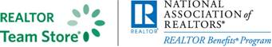
LRRArealtorteamstore.com
Buy REALTOR® logo merchandise and save 5% using your Little Rock REALTORS® Association discount code.
Enter LRRA under the area marked “Discount Coupon” during checkout at step 2 of 4.

WELCOME TO LRRA OUR NEWEST REALTOR MEMBERS
Realtors:

WELCOME TO LRRA OUR NEWEST REALTOR MEMBERS!

Taylor Gilley | EXP Realty
Karina Aguilera | Truman Ball Real Estate
Andrea Dolphin | Genesis Realty
Tanika Walton | Keller Williams Little Rock
Jasmine Michell | Vylla Home
John Eaves | Keller Williams Little Rock
Tajah Davis | Innovative Realty
Jennifer Wood | Re/Max Elite
Jolanda Young | Unlimited Properties Realty
Bridget Uchendu | Crye-Leike Realtors Kanis Branch
Amberla McGoogan | Real Broker
Douglas Tipton | Keller Williams Little Rock
Tracy Aqcuard | EXP Realty
Spencer Ramsey | Keller Williams Little Rock
Kaylor Duncan | Keller Williams Little Rock
Clinton McDonald | Adkins & Associates
Latoya Wright | SSD Realty Group
John Pickell | Coldwell Banker RPM Group Midtown
Rodney Sanders | Keller William Little Rock
Sakeysha Hunter | Vylla Homes

LRRA Mission Statement: Little Rock REALTORS® Association provides its membership the opportunity to enhance REALTOR® performance through education, technology and integrity.
LRRA Vision Statement: Little Rock REALTORS® Association strives to serve as a voice for local REALTORS®, encourage a high level of ethics, education and professionalism among its members and to advocate on behalf of the profession.
LRRA Core Values: Education, Professionalism, Support of Members, Value to the Membership, Integrity, Property Rights, Voice to lobby and promote, Serve and Support our members and community, Advocacy and Ethics.

2024 LRRA Board Of Directors:
President: Matty Ross – The Charlotte John Company
President Elect: Conley Golden – The Janet Jones Company
Past President: Fletcher Hanson – Moses Tucker Partners
Secretary: Whitney McLellan – McLellan & Associates Real Estate
Treasurer: Ross McCain – The McCain Company
Board:
Jon Kennon – iRealty Arkansas
Melissa Glidden – Capital Sotheby’s International
Laura Rogers- River Trail Properties
Robert Klein – The Property Group
Heather Stuart- Signature Properties
Kaye Chambers – Re/Max Elite
John Selva – Engel & Volkers
Kathy Patton – Crye-Leike Realtors - Kanis
Erica Isben – The Charlotte John Company

