Little Rock REALTORS® Association provides its membership the opportunity to enhance REALTOR® performance through education, technology and integrity.
Little Rock REALTORS
October 2023
CALENDAR OF EVENTS

October 3rd- YPN from 5 to 7 PM at Cantina Laredo
October 12th- Lunch & Learn at LRRA starting at 11:30 AM
October 16th- LAC & BOD Meetings
October 19th- October General Meeting at Country Club of LR at 9:30 AM
October 31st- Halloween

October General Meeting
Join us on October 19th from 9:30 to 11:30 AM at Country Club of Little Rock for the last general meeting of 2023. Our speaker will be Affiliate Member, Billy Roehrenbeck, with Pulaski Co Title. Billy will be talking to us about AI and daul-factor authentication. During this meeting will we will also induct new members and install the 2024 Board of Directors. Cost is $25 per member and $35 per guest. Tickets can be purchased through your membership portal at www.LRRA.com
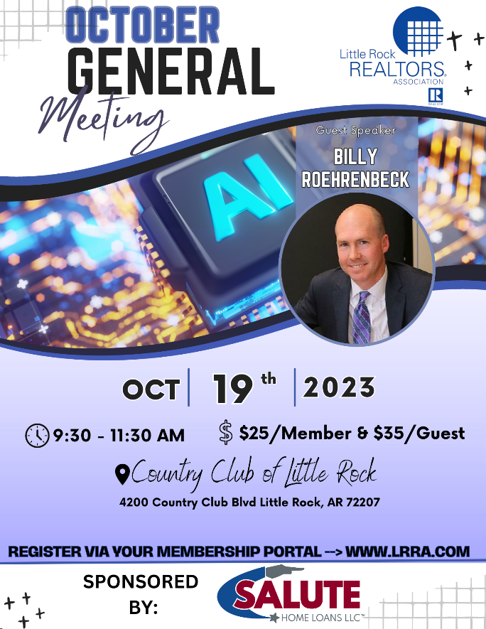
Lunch & Learn
Join us on October 12th from 11:30 to 12:30 here at LRRA for a free Lunch & Learn! Enjoy a free meal from Mockingbird Bar & Tacos as you learn about improving your real estate business practices. Because being a great Realtor doesn't automatically make you a great businessman, Capital Real Estate Advisors is proud to present, Victor Werley. Victor is a professional financial consultant based in Little Rock for over 20 years. He will be speaking about the effective strategies through investments and smart taxation to secure and grow your wealth, while also positioning yourself to minimize taxes and pass much of that wealth on to future generations. Don't miss this great opportunity to learn from an experienced businessman and trusted financial advisor while you treat yourself to some of the best tacos in Little Rock.
Seating is limited so please RSVP to: info@capitalrea.net or call 501-420-4097

Dues Increase in 2023
The National Association of Realtors has also elected to increase the National Dues from $150 to $156… a $6 increase. Local and State dues are remaining the same. So primary members of LRRA will pay $561 in annual dues for 2024, up from $555 in 2023.

2023 ORIENTATION
Next Orientation
If you have missed your scheduled Orientation date or missed being inducted in the past year, please notify membership@LRRA.com so you can complete the process and not have to start the process all over.
Please note that you have two opportunities to attend an orientation from the time that you sign up for membership. If you miss those two opportunities you will be placed on inactive status and your CARMLS access will be inactivated until you have completed orientation. You will be notified by email when you become eligible to attend New Member Orientation. Our next Orientation will be in person, at our office on March 9th.

AFFILIATE SPONSORSHIP OPPORTUNITIES
LRRA is looking for sponsors for the 2023 year. Please contact Libby for sponsorship opportunities. We try not to have sponsors from the same industry, but we cannot guarantee it won’t happen...i.e. 2 mortgage companies, 2 inspectors, etc. Please email Libby@LRRA.com and cc Jesse@LRRA.com to let us know you want to sponsor and we will let you know if the sponsorship is open.
We have general Meetings, Orientations, Lunch and Learns, REALTOR® Awards of Distinction, Broker meeting, and many more opportunities to sponsor in 2023. Thank you for all you do to support the Little Rock REALTORS® Association and our members!
To our LRRA members: Please take note of the Affiliate members who sponsor our events. They are investing in you and we hope you will take note and invest in them in return by giving them your business.

YPN EVENTS BEGINNING AGAIN!

YPN (Young Professionals Network) will now be the FIRST Tuesday of each month, except for January and July of 2023. The next YPN will be October 3rd at Cantina Laredo from 5 to 7 PM! Thank you to our sponsors: Pulaski Co Title, First Security Mortgage, New American Funding and ProLand Title. We take cash or credit/debit card at the door: $5 REALTOR®s, $10 Affiliates, $15 Guests. Any Affiliate looking to sponsor please email jesse@LRRA.com

Legislative Affairs
Little Rock Mayor Frank Scott has said he will pursue his proposed sales tax increase on the November 2024 ballot. To put the issue on the ballot this November, as was initially discussed, the City Board would have had to approve the measure by September 5. The Mayor and city staff held a series of seven public meetings on the proposal before the Mayor announced he is looking at a November 2024 vote.

The plan includes several “pillars of focus,” including public safety, public infrastructure, parks and recreation, and port and economic development. Specifics include a proposed indoor/outdoor sports complex at War Memorial, street and sidewalk improvements ($115 million), Zoo enhancements ($40 million), and additional police and fire vehicles and equipment ($65 million).

Look for improvements on West Markham. Metroplan recently announced that a handful of communities around Central Arkansas had received $16.5 million in federal grant money, including the City of Little Rock. Little Rock will use the money to reconstruct West Markham from Cedar Street to Pearl Avenue. That segment of road will be reduced from four lanes to two lanes, with a central turn lane. Sidewalks on that stretch will be widened to make the area more pedestrian friendly.

Meanwhile, the Arkansas General Assembly wrapped up a four-day special session in September. In addition to passing legislation that prohibits state and local governments from mandating COVID-19 vaccines, lawmakers voted to lower the top individual and corporate income tax rates, while also providing a one-time $150 income tax credit for taxpayers making less than $90,000 per year. The top corporate rate went from 5.1% to 4.8%, while the individual rate dropped from 4.7% to 4.4%. Legislators also passed a measure to amend the state’s Freedom of Information Act (FOIA), shielding records related to the security of the Governor and certain elected officials. Initially proposed bills would have made broader changes to FOIA, but those were scaled back to address only security. The 2024 session will be for budget issues only and will convene in April. In the meantime, legislative committees continue to meet – many of them monthly.

NEW MEMBERS
Brokers, we work very, very hard to get your agents onboarded as fast as we can, however, this time of year takes longer, because of the high instances of transfers, new members and new offices at this time. Please make sure to let your new agents know that joining, transferring, or changing information takes longer than normal at this time. Please make sure they know it may take up to 24 hours to get all the information needed and uploaded before they can expect to have access to the MLS or forms.

TRANSFERS
If you are planning on transferring, please remember that it may take a few days longer than usual because the AREC is very busy at this time. If transferring offices, please submit the LRRA office transfer form and $35 to the Little Rock REALTORS® Association once you’ve transferred with the AREC. Please remember anything else may take longer than usual and everyone should expect it to take at least 24 hours to get you onboarded.

LRRA EDUCATION ROOM RENTAL
LRRA rents its Education Room and Board Room out to interested groups in need of a classroom or lecture space. The Education Room is perfect for meeting space and seats up to 55. Our Education Room comes equipped with a large white board, a projector, overhead projector, podium, screen, 55 “television and Internet connections for all your connection needs. Our building is also equipped with Wi-Fi. Please call Libby at 225-1987 for competitive rental rates.

Financial Wellness Webinars
The NAR is offering Financial Wellness Webinars which are designed to help REALTORS® understand financial topics on a deeper level. No matter the career stage or level of financial planning, these webinars are helpful and informative to all members. Go to their website to learn more and get signed up.
CODE OF ETHICS vs. CE
The Code of Ethics….is a course each NAR-ARA-LRRA member takes upon joining the association and every three years after, for the duration of your membership. The Code of Ethics is what distinguishes our members from being just a licensee. Passing the Code of Ethics is what distinguishes a REALTOR® from a real estate agent. In order to reaffirm your commitment to being a REALTOR® you must retake the course every three years. It is on line and free. The current cycle ends December 31st, 2021.
Your Code of Ethics is not necessarily a continuing education class. It can be, but is not CE unless clearly stated by the instructor.
Each time you take Code of Ethics courses, either on line or through a licensed instructor, it is the agent’s responsibility to send a copy to their local board for coding into the NRDS system.
Code of Ethics does not go to the Arkansas Real Estate Commission…..it goes to your local board for entry into the NRDS database.
CE is what is required by the Arkansas Real Estate Commission for you to maintain a license to practice real estate in Arkansas.

NAR CODE OF ETHICS REQUIREMENT
We want to make you aware of a new NAR rule concerning Code of Ethics. Please make sure your agents are aware of this new NAR requirement.
If your agent believes he/she has taken it then they will need to provide us with a copy of their certificate showing the course included NAR required Code of Ethics.
We do not necessarily get notice that the agent completed the requirement when the educator turns the course list into the Commission. It is up to each agent to provide LRRA with a copy of their certificate to show they have completed the 2.5 required hours.
Noncompliance will force us to inactivate your membership. We do not want to do that! Please make sure you take the course at least 1 time every 3 years.

NEED YOUR NRDS NUMBER?
Do you need your NRDS number to pay dues, make a reservation, log on to REALTOR®.org?
If you joined the REALTORS® association through LRRA, your NRDS number will begin with 1280.
If you don’t have it here are some simple ways to find it:
- Look at the white address label on the cover of YOUR REALTOR® magazine . Your NRDS number will be there.
- Check last year’s billing invoice in your Brokers administrative office, it is listed on each billing invoice.
- Once you have it, write it on the back of your pocket card for safe keeping.

REALTOR® TEAM STORE- LRRA DISCOUNT FOR MEMBERS ONLY
Want to order REALTOR® merchandise and receive a discount?
Well now you can! Go to the address listed below!
LRRArealtorteamstore.com
Buy REALTOR® logo merchandise and save 5% using your Little Rock REALTORS® Association discount code.
Enter LRRA under the area marked “Discount Coupon” during checkout at step 2 of 4.

WELCOME TO LRRA OUR NEWEST REALTOR MEMBERS
Realtors:
Summer Shanklin | Mayven Realty Group
Aleeyah Nurredin | Compass Rose Realty
Darla Green | Todd Armstrong Real Estate
Towonda Armstrong | Keller Williams Realty LR
James Hadley | Brokers Guild
Paul Minton | Allied Brokers, Inc.
Larry Carpenter | Allied Brokers, Inc.
Pavia Jones | Crye-Leike Kanis Brancy
April Gifford | NextHome BHB Property Advisors
Christa Graves | Signature Properties

WELCOME TO LRRA OUR NEWEST REALTOR MEMBERS!

LRRA Mission Statement: Little Rock REALTORS® Association provides its membership the opportunity to enhance REALTOR® performance through education, technology and integrity.
LRRA Vision Statement: Little Rock REALTORS® Association strives to serve as a voice for local REALTORS®, encourage a high level of ethics, education and professionalism among its members and to advocate on behalf of the profession.
LRRA Core Values: Education, Professionalism, Support of Members, Value to the Membership, Integrity, Property Rights, Voice to lobby and promote, Serve and Support our members and community, Advocacy and Ethics.
Melissa Glidden – Capital Sotheby’s International

LITTLE ROCK REALTORS® ASSOCIATION, INC.

2023 OFFICERS AND DIRECTORS

OFFICERS

President
-

Fletcher Hanson
-

Moses Tucker Partners

President Elect
-
Matty Ross
-
-The Charlotte John Company

Treasurer
-

Jon Kennon
-
iRealty Arkansas

Secretary
-
Mitsy Tharp
-
Signature Properties

Past President
-
April Findlay
-
-The Charlotte John Company

DIRECTORS

Ross McCain – The McCain Company
-

John Selva
-
Engel & Volkers
-

Kaye Chambers
-
-REMAX Elite

Jennif
er Kronenberger
-
-JK Real Estate

Patrick McKay
-
The Property Group

Stacy Hamilton
-
Coldwell Banker RPM Group - WLR

Conley Jones
-
-The Janet Jones Company

-

Whitney McLellan

-McLellan & Associates Real Estate

Kathy Patton

-Cry-Leike REALTORS – Kanis Branch

