Little Rock REALTORS® Association provides its membership the opportunity to enhance REALTOR® performance through education, technology and integrity.
Little Rock REALTORS
April 2024
CALENDAR OF EVENTS

April 2nd- YPN @ Top Golf from 5 to 7 PM
April 8th- Office Closed for Solar Eclipse
April 15th- LAC & BOD Meetings
April 17-19th- Office Closed For Off-site Staff Training
April 25th- April General Meeting @ Next Level Events

April General Meeting
Our April General Meeting will be on April 25th from 9 to 11 AM at Next Level Events (1400 W Markham St). The speaker for the meeting will be Tim Grooms. Tim will be giving a legal update regarding NAR. During this meeting we will also induct new members and introduce ARA’s new CEO, Stephanie White and ARA President Jennifer Welch. Tickets for members are $25/each and tickets for guests are $35/each; a continental breakfast will be served.
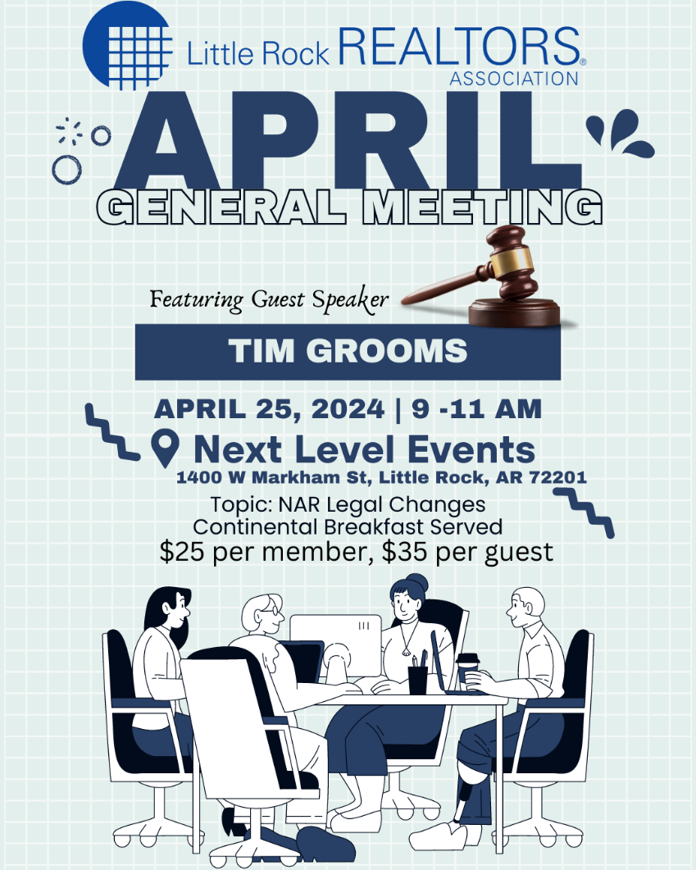

YPN EVENTS BEGINNING AGAIN!

YPN (Young Professionals Network) will now be the FIRST Tuesday of each month, except for January and July of 2024. The next YPN will be April 2nd at Top Golf from 5 to 7 PM! Thank you to our sponsors: Edge Home Finance, Cadence Bank and Home Team Inspection Services. We take cash or credit/debit card at the door: $10 for everyone. Any Affiliate looking to sponsor please email jesse@LRRA.com

2024 ORIENTATION
Next Orientation
If you have missed your scheduled Orientation date or missed being inducted in the past year, please notify Elle@LRRA.com so you can complete the process and not have to start the process all over.
Please note that you have two opportunities to attend an orientation from the time that you sign up for membership. If you miss those two opportunities you will be placed on inactive status and your CARMLS access will be inactivated until you have completed orientation. You will be notified by email when you become eligible to attend New Member Orientation. Our next Orientation will be in person, at our office on March 7th.

AFFILIATE SPONSORSHIP OPPORTUNITIES
LRRA is looking for sponsors for the 2024 year. Please contact Libby for sponsorship opportunities. We try not to have sponsors from the same industry, but we cannot guarantee it won’t happen...i.e. 2 mortgage companies, 2 inspectors, etc. Please email stacy@lrra.com and cc Jesse@LRRA.com to let us know you want to sponsor and we will let you know if the sponsorship is open.
We have general Meetings, Orientations, Lunch and Learns, REALTOR® Awards of Distinction, Broker meeting, and many more opportunities to sponsor in 2024. Thank you for all you do to support the Little Rock REALTORS® Association and our members!
To our LRRA members: Please take note of the Affiliate members who sponsor our events. They are investing in you and we hope you will take note and invest in them in return by giving them your business.

Legislative Affairs
Local leaders heard an update on the “Downtown Little Rock Master Plan” during a recent presentation to Downtown Rotary. The project has been undertaken by the Little Rock Downtown Partnership and funded by the City of Little Rock. It will look at development and urban design, streets and mobility, infrastructure and transportation, and parks and open space. Urban design firm Sasaki is leading a study for the Plan, and a draft is expected to be complete by May. The city used $745,000 in ARPA money to pay for the study/plan. A representative from Sasaki provided an update on the process, telling attendees that outside of bigger infrastructure changes, he sees a “quick win” as a “reorientation towards the river,” as well as a focus on outdoor recreation. He said Chattanooga and Greenville have used a recreation focus to attract talent and improve quality of life for residents.

Meanwhile, a panel of Little Rock executives talked about the community’s growth progress and potential at a PowerUp Series discussion hosted recently by Little Rock Regional Chamber of Commerce. Participants were Patrick Schueck of Lexicon, Inc.; Tab Townsell, Public Works Director for Pulaski County; Cathy Tuggle of Apartment Hunters, and Troy Wells, president and CEO of Baptist Health. The group talked about economic growth in the area, including what Wells says has been an improvement in labor supply in health and technology fields. Schueck also mentioned that supply chain issues that caused businesses to struggle the past couple of years post-pandemic have finally improved. Tuggle said she’s seen a 20% increase across the board in apartment rental rates, but at the same time, occupancy up (the best in 25 years, she said). All agreed that measures to improve quality of life are imperative for growth in the community. The next panel discussion is April 24 at the Clinton Library and will focus on outdoor recreation.

(Information for this article was taken from local news reports.)

HOUSE LOGIC
HouseLogic.com is a free source of information and tools — from the NATIONAL ASSOCIATION OF REALTORS® — that can help you make smart and timely decisions about your home.
HouseLogic.com is a site for homeowners who want smart solutions to enjoy, improve, and maintain their home; for buyers ready to find their happy place; and for sellers ready for their next chapter. No matter where you are in your home ownership journey, HouseLogic is the place to dive deep into such topics as home improvements (building equity!), the best ways to save on home expenses, house-hunting insights, and tips for prepping your home to sell — fast.
Why do REALTORS® offer HouseLogic?
REALTORS®, members of the NATIONAL ASSOCIATION OF REALTORS®, have been champions of home ownership rights and opportunities for more than a century. Helping you become a more informed, confident homeowner is important to the stability and value of the housing market — and your overall enjoyment of your home.
What’s the best way to get familiar with the site?
To get familiar with their content, explore the offerings in each of the three main navigation areas at the top right of every page of the site: Buy & Sell, Improve, and Your Money.
Also, follow (and connect with) with them on Facebook, Twitter, Pinterest, Instagram and YouTube.

NEW MEMBERS
Brokers, we work very, very hard to get your agents onboarded as fast as we can, however, this time of year takes longer, because of the high instances of transfers, new members and new offices at this time. Please make sure to let your new agents know that joining, transferring, or changing information takes longer than normal at this time. Please make sure they know it may take up to 24 hours to get all the information needed and uploaded before they can expect to have access to the MLS or forms.

TRANSFERS
If you are planning on transferring, please remember that it may take a few days longer than usual because the AREC is very busy at this time. If transferring offices, please submit the LRRA office transfer form and $35 to the Little Rock REALTORS® Association once you’ve transferred with the AREC. Please remember anything else may take longer than usual and everyone should expect it to take at least 24 hours to get you onboarded.

LRRA EDUCATION ROOM RENTAL
LRRA rents its Education Room and Board Room out to interested groups in need of a classroom or lecture space. The Education Room is perfect for meeting space and seats up to 55. Our Education Room comes equipped with a large white board, a projector, overhead projector, podium, screen, 55 “television and Internet connections for all your connection needs. Our building is also equipped with Wi-Fi. Please call Jesse at 225-1987 for competitive rental rates.

Financial Wellness Webinars
The NAR is offering Financial Wellness Webinars which are designed to help REALTORS® understand financial topics on a deeper level. No matter the career stage or level of financial planning, these webinars are helpful and informative to all members. Go to their website to learn more and get signed up.
CODE OF ETHICS vs. CE
The Code of Ethics….is a course each NAR-ARA-LRRA member takes upon joining the association and every three years after, for the duration of your membership. The Code of Ethics is what distinguishes our members from being just a licensee. Passing the Code of Ethics is what distinguishes a REALTOR® from a real estate agent. In order to reaffirm your commitment to being a REALTOR® you must retake the course every three years. It is on line and free. The current cycle ends December 31st, 2024.
Your Code of Ethics is not necessarily a continuing education class. It can be, but is not CE unless clearly stated by the instructor.
Each time you take Code of Ethics courses, either on line or through a licensed instructor, it is the agent’s responsibility to send a copy to their local board for coding into the NRDS system.
Code of Ethics does not go to the Arkansas Real Estate Commission…..it goes to your local board for entry into the NRDS database.
CE is what is required by the Arkansas Real Estate Commission for you to maintain a license to practice real estate in Arkansas.

NAR CODE OF ETHICS REQUIREMENT
We want to make you aware of a new NAR rule concerning Code of Ethics. Please make sure your agents are aware of this new NAR requirement.
If your agent believes he/she has taken it then they will need to provide us with a copy of their certificate showing the course included NAR required Code of Ethics.
We do not necessarily get notice that the agent completed the requirement when the educator turns the course list into the Commission. It is up to each agent to provide LRRA with a copy of their certificate to show they have completed the 2.5 required hours.
Noncompliance will force us to inactivate your membership. We do not want to do that! Please make sure you take the course at least 1 time every 3 years.

NEED YOUR NRDS NUMBER?
Do you need your NRDS number to pay dues, make a reservation, log on to REALTOR®.org?
If you joined the REALTORS® association through LRRA, your NRDS number will begin with 1280.
If you don’t have it here are some simple ways to find it:
- Once you have it, write it on the back of your pocket card for safe keeping.
- You can locate your number by going to www.LRRA.com and click on the link in the top left corner of our website.

REALTOR® TEAM STORE- LRRA DISCOUNT FOR MEMBERS ONLY
Want to order REALTOR® merchandise and receive a discount?
Well now you can! Go to the address listed below!
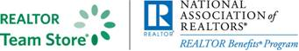
LRRArealtorteamstore.com
Buy REALTOR® logo merchandise and save 5% using your Little Rock REALTORS® Association discount code.
Enter LRRA under the area marked “Discount Coupon” during checkout at step 2 of 4.

WELCOME TO LRRA OUR NEWEST REALTOR MEMBERS
Realtors:

WELCOME TO LRRA OUR NEWEST REALTOR MEMBERS!

Logan Caughron | Keller Williams Little Rock
Megan Morrow | Rackley Realty
Shannon Phillips | Keller Williams Little Rock
Jade Brandon | Keller Williams Little Rock
Joshua Johnson | Keller Williams Little Rock
Jacob Palmer | TMK Properties

LRRA Mission Statement: Little Rock REALTORS® Association provides its membership the opportunity to enhance REALTOR® performance through education, technology and integrity.
LRRA Vision Statement: Little Rock REALTORS® Association strives to serve as a voice for local REALTORS®, encourage a high level of ethics, education and professionalism among its members and to advocate on behalf of the profession.
LRRA Core Values: Education, Professionalism, Support of Members, Value to the Membership, Integrity, Property Rights, Voice to lobby and promote, Serve and Support our members and community, Advocacy and Ethics.

2024 LRRA Board Of Directors:
President: Matty Ross – The Charlotte John Company
President Elect: Conley Golden – The Janet Jones Company
Past President: Fletcher Hanson – Moses Tucker Partners
Secretary: Whitney McLellan – McLellan & Associates Real Estate
Treasurer: Ross McCain – The McCain Company
Board:
Jon Kennon – iRealty Arkansas
Melissa Glidden – Capital Sotheby’s International
Laura Rogers- River Trail Properties
Robert Klein – The Property Group
Heather Stuart- Signature Properties
Kaye Chambers – Re/Max Elite
John Selva – Engel & Volkers
Kathy Patton – Crye-Leike Realtors - Kanis
Erica Isben – The Charlotte John Company

