Little Rock REALTORS® Association provides its membership the opportunity to enhance REALTOR® performance through education, technology and integrity.
Little Rock REALTORS
August 2023
CALENDAR OF EVENTS

August 1st – YPN at Cantina Laredo
August 10th- New Member Orientation at LRRA
August 11th- Deadline for Back To School Supplies Drive
August 17th- August General Meeting at Chenal Country Club
August 21st- LAC and BOD Meetings

August General Meeting
Join us on August 17th at Chenal Country Club from 9:30 AM to 11:30 AM for our August General Meeting! The guest speaker for this meeting will be Chad E. Cooper who will be giving a talk entitled "Slowing down in order to go fast: How to increase your revenue and increase the energy in your personal life." New members will be inducted, we will have BOD nominations and the ROTY for 2023 will all be announced during this meeting as well. The meeting begins at 9:30 AM and a continental breakfast will be served. Any q's please email jesse@LRRA.com. Our Guest Speaker will be Chad Cooper. Chad E Cooper is a high-performance coach whose clients include world record holders, Olympians, internationally acclaimed artists and musicians, MVPs from every major sport and Fortune 500 CEOs. A published, peer-reviewed author and recognized speaker on optimal human performance; Chad E Cooper has been featured in Forbes, Thrive Global, CBS Radio, Huffington Post, McKesson, and Sirius XM Network. The host Legendary Lifestyles radio show. Chad is the founder of Legendary Life® assisting people to break through to the life they have always wanted. Chad E Cooper is also the proud founder of Factive Nautics Coaching.

Announcement of New Slate of Officers for 2024

Dear LRRA Members,
We are writing to you today to announce the proposed 2024 slate of officers and directors. The Nominating Committee met and is happy to announce there will be a vote to elect this slate of Officers and Directors on August 17, 2023 at Chenal CC. Please register now for Program featuring Chad Cooper.
2024 PROPOSED OFFICERS AND DIRECTORS

OFFICERS:
Matty Ross President
The Charlotte John Company
Conley Golden President Elect
The Janet Jones Company
Ross McCain Treasurer
The McCain Company
Whitney McLellan Secretary
McLellan & Associates Real Estate
Fletcher Hanson Past President
Moses Tucker Partners
Directors:
1 Years Remaining- Ends Dec.2024
Melissa Glidden
Capital Sotheby’s International
Stacy Hamilton
Coldwell Banker RPM
Kathy Patton
Crye-Leike Realty
Kaye Chambers
ReMax Elite
2 Years Remaining (2025)
John Selva
Engel & Volkers
Erica Ibsen
The Charlotte John Company
Jon Kennon
iRealty Arkansas
3 Years Remaining (Ends Dec 2026)
Laura Rogers
River Trail Properties
Robert Klein
The Property Group

Heather Stuart
Signature Properties

School Supply Drive
Hey Little Rock Realtors!
It’s time for the Little Rock Realtors Association Back TO SCHOOL Supply Drive!
1. Collect donations at your office
2. Drop by the LRRA office for a pic of your good deed.
*all donations need to be delivered to LRRA offices by Friday, August 11th at NOON

Dues Increase in 2023
The National Association of Realtors has also elected to increase the National Dues from $150 to $156… a $6 increase. Local and State dues are remaining the same. So primary members of LRRA will pay $561 in annual dues for 2024, up from $555 in 2023.

CE Course
The last chance to take CE through LRRA for $35 per member is in September. The course for sales agents and associate brokers will be on September 13th from 9 AM to 5 PM and the CE course for Brokers ONLY will be on September 14th from 9 AM to 5 PM. The course is now open for registration. Both CE classes will be taught by Keith Montgomery of MidSouth Real Estate Academy at the auditorium in St. Vincent Hospital located at 2 St. Vincent Circle. 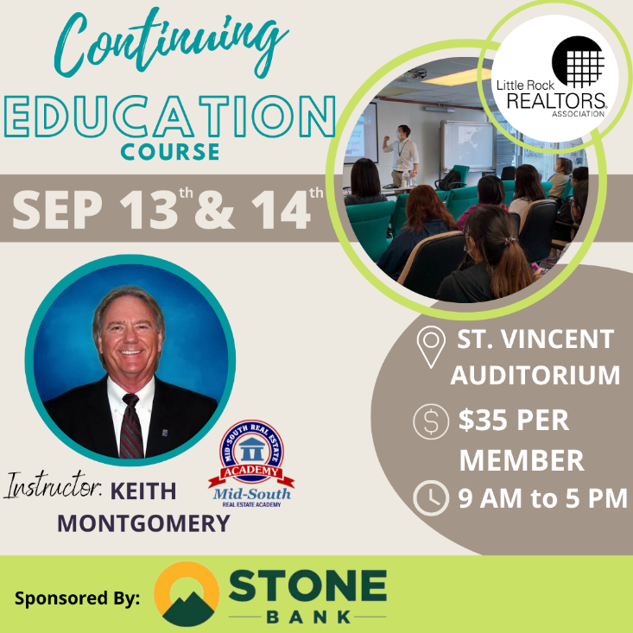

2023 ORIENTATION
Next Orientation
If you have missed your scheduled Orientation date or missed being inducted in the past year, please notify Nick@LRRA.com so you can complete the process and not have to start the process all over.
Please note that you have two opportunities to attend an orientation from the time that you sign up for membership. If you miss those two opportunities you will be placed on inactive status and your CARMLS access will be inactivated until you have completed orientation. You will be notified by email when you become eligible to attend New Member Orientation. Our next Orientation will be in person, at our office on March 9th.

AFFILIATE SPONSORSHIP OPPORTUNITIES
LRRA is looking for sponsors for the 2023 year. Please contact Libby for sponsorship opportunities. We try not to have sponsors from the same industry, but we cannot guarantee it won’t happen...i.e. 2 mortgage companies, 2 inspectors, etc. Please email Libby@LRRA.com and cc Jesse@LRRA.com to let us know you want to sponsor and we will let you know if the sponsorship is open.
We have general Meetings, Orientations, Lunch and Learns, REALTOR® Awards of Distinction, Broker meeting, and many more opportunities to sponsor in 2023. Thank you for all you do to support the Little Rock REALTORS® Association and our members!
To our LRRA members: Please take note of the Affiliate members who sponsor our events. They are investing in you and we hope you will take note and invest in them in return by giving them your business.

YPN EVENTS BEGINNING AGAIN!

YPN (Young Professionals Network) will now be the FIRST Tuesday of each month, except for January and July of 2023. The next YPN will be August 1st at Cache Restaurant from 5 to 7 PM! Thank you to our sponsors: Best Title, The Brooks Agency, FirstTrust Home Loans, New American Funding and ProLand Title. We take cash or credit/debit card at the door: $5 REALTOR®s, $10 Affiliates, $15 Guests. Any Affiliate looking to sponsor please contact our YPN Chair Meg France by emailing
Meg@jonunderhill.com

Legislative Affairs
Proposed Sales Tax
Mayor Frank Scott, Jr. has proposed raising Little Rock’s sales tax 1 percentage point, which would bring the overall rate to 9.625%. Scott outlined the proposal at a meeting of the Little Rock City Board July 27. The Board would have to approve the proposal in order for it to be on the November 14 ballot. The proposal would generate $600 million in revenue over 10 years, with $371.5 million marked for capital improvements and $228.5 million for new operating expenses. Mayor Scott proposes spending categories to include parks and quality of life, public infrastructure, public safety, port and economic development, homelessness, and neighborhood programs. Projects would include construction of an indoor/outdoor sports complex at War Memorial Park for soccer, softball, baseball and basketball, to serve as a regional facility for youth sports. The Little Rock Zoo would receive $30 million for capital improvements. New revenue would be used entirely for operating expenses in the public safety category.
Scott initially proposed sunsetting the tax after 10 years, but after discussion from city directors, he said the sunset date would likely be removed. Some directors expressed concerns that the proposal is being pushed through too quickly, and others indicted it is not as narrow a proposal as they’d like to see. The deadline to call the election is September 5. Otherwise, the next opportunity for a tax referendum would be March 5, during the primary election.

LRPD Recruitment
Meanwhile, the City of Little Rock continues a focus on reducing the number of vacancies in the Little Rock Police Department (LRPD). Mayor Frank Scott earlier this month said he plans to reduce vacancies by 40% by the end of the year. Currently, LRPD has about 90 officer vacancies, with 30 others on extended leave. Chief Heath Helton has said he could do a lot more once those spots are filled. Incentives like a $10,000 bonus to applicants who graduate from the police academy and a $5,000 moving bonus have helped attract new applicants. Twenty-one recruits graduated from the most recent recruiting class, with more than 40 applicants in the upcoming recruiting class. Around 35-40 officers retire from LRPD each year, on average.

*Information for this article was obtained from local media reports.

NEW MEMBERS
Brokers, we work very, very hard to get your agents onboarded as fast as we can, however, this time of year takes longer, because of the high instances of transfers, new members and new offices at this time. Please make sure to let your new agents know that joining, transferring, or changing information takes longer than normal at this time. Please make sure they know it may take up to 24 hours to get all the information needed and uploaded before they can expect to have access to the MLS or forms.

TRANSFERS
If you are planning on transferring, please remember that it may take a few days longer than usual because the AREC is very busy at this time. If transferring offices, please submit the LRRA office transfer form and $35 to the Little Rock REALTORS® Association once you’ve transferred with the AREC. Please remember anything else may take longer than usual and everyone should expect it to take at least 24 hours to get you onboarded.

LRRA EDUCATION ROOM RENTAL
LRRA rents its Education Room and Board Room out to interested groups in need of a classroom or lecture space. The Education Room is perfect for meeting space and seats up to 55. Our Education Room comes equipped with a large white board, a projector, overhead projector, podium, screen, 55 “television and Internet connections for all your connection needs. Our building is also equipped with Wi-Fi. Please call Libby at 225-1987 for competitive rental rates.

Financial Wellness Webinars
The NAR is offering Financial Wellness Webinars which are designed to help REALTORS® understand financial topics on a deeper level. No matter the career stage or level of financial planning, these webinars are helpful and informative to all members. Go to their website to learn more and get signed up.
CODE OF ETHICS vs. CE
The Code of Ethics….is a course each NAR-ARA-LRRA member takes upon joining the association and every three years after, for the duration of your membership. The Code of Ethics is what distinguishes our members from being just a licensee. Passing the Code of Ethics is what distinguishes a REALTOR® from a real estate agent. In order to reaffirm your commitment to being a REALTOR® you must retake the course every three years. It is on line and free. The current cycle ends December 31st, 2021.
Your Code of Ethics is not necessarily a continuing education class. It can be, but is not CE unless clearly stated by the instructor.
Each time you take Code of Ethics courses, either on line or through a licensed instructor, it is the agent’s responsibility to send a copy to their local board for coding into the NRDS system.
Code of Ethics does not go to the Arkansas Real Estate Commission…..it goes to your local board for entry into the NRDS database.
CE is what is required by the Arkansas Real Estate Commission for you to maintain a license to practice real estate in Arkansas.

NAR CODE OF ETHICS REQUIREMENT
We want to make you aware of a new NAR rule concerning Code of Ethics. Please make sure your agents are aware of this new NAR requirement.
If your agent believes he/she has taken it then they will need to provide us with a copy of their certificate showing the course included NAR required Code of Ethics.
We do not necessarily get notice that the agent completed the requirement when the educator turns the course list into the Commission. It is up to each agent to provide LRRA with a copy of their certificate to show they have completed the 2.5 required hours.
Noncompliance will force us to inactivate your membership. We do not want to do that! Please make sure you take the course at least 1 time every 3 years.

NEED YOUR NRDS NUMBER?
Do you need your NRDS number to pay dues, make a reservation, log on to REALTOR®.org?
If you joined the REALTORS® association through LRRA, your NRDS number will begin with 1280.
If you don’t have it here are some simple ways to find it:
- Look at the white address label on the cover of YOUR REALTOR® magazine . Your NRDS number will be there.
- Check last year’s billing invoice in your Brokers administrative office, it is listed on each billing invoice.
- Once you have it, write it on the back of your pocket card for safe keeping.

REALTOR® TEAM STORE- LRRA DISCOUNT FOR MEMBERS ONLY
Want to order REALTOR® merchandise and receive a discount?
Well now you can! Go to the address listed below!
LRRArealtorteamstore.com
Buy REALTOR® logo merchandise and save 5% using your Little Rock REALTORS® Association discount code.
Enter LRRA under the area marked “Discount Coupon” during checkout at step 2 of 4.

WELCOME TO LRRA OUR NEWEST REALTOR MEMBERS
Realtors:
Kimberly Anne Robinson | Real Estate Central
Ashley Bourne | Superior Real Estate
Aracely Galan | Casa Americana Realty
Monique Thompson | EXP Realty
Travis Henserson | Arkansas Property Management and RE
Rebecca Adams | The Legacy Team
Andrea Cheshier | Keller Williams Realty WLR
Shaundara Powell | Dawn Realty & Associates
Jeremy Phifer | Start to Finish Realty
Melissa Simpson | Keller Williams
Alix Le Goff-Michel | Keller Williams Realty LR
Tonek Kneeland | Keller Williams Realty LR
Kevin Hunt (KJ) | Real Estate Central
Governor Foreman | HomesWork Realty
Wendy Musteen | Epic Real Estate
Rhonda Murphy | Re/Max Elite
Daylen Mack | Keller Williams Realty LR
Dillon Fogle | Pillar Realty & Management
John Lindsey | Paragon Group Realty
Jonathan Viguerie | REI Realty
Caroline Otwell | RPM Group
Greg Churan | Engel & Volkers-WLR

WELCOME TO LRRA OUR NEWEST REALTOR MEMBERS!

LRRA Mission Statement: Little Rock REALTORS® Association provides its membership the opportunity to enhance REALTOR® performance through education, technology and integrity.
LRRA Vision Statement: Little Rock REALTORS® Association strives to serve as a voice for local REALTORS®, encourage a high level of ethics, education and professionalism among its members and to advocate on behalf of the profession.
LRRA Core Values: Education, Professionalism, Support of Members, Value to the Membership, Integrity, Property Rights, Voice to lobby and promote, Serve and Support our members and community, Advocacy and Ethics.
Melissa Glidden – Capital Sotheby’s International

LITTLE ROCK REALTORS® ASSOCIATION, INC.

2023 OFFICERS AND DIRECTORS

OFFICERS

President
-

Fletcher Hanson
-

Moses Tucker Partners

President Elect
-
Matty Ross
-
-The Charlotte John Company

Treasurer
-

Jon Kennon
-
iRealty Arkansas

Secretary
-
Mitsy Tharp
-
Signature Properties

Past President
-
April Findlay
-
-The Charlotte John Company

DIRECTORS

Ross McCain – The McCain Company
-

John Selva
-
Engel & Volkers
-

Kaye Chambers
-
-REMAX Elite

Jennif
er Kronenberger
-
-JK Real Estate

Patrick McKay
-
The Property Group

Stacy Hamilton
-
Coldwell Banker RPM Group - WLR

Conley Jones
-
-The Janet Jones Company

-

Whitney McLellan

-McLellan & Associates Real Estate

Kathy Patton

-Cry-Leike REALTORS – Kanis Branch

