Little Rock REALTORS® Association provides its membership the opportunity to enhance REALTOR® performance through education, technology and integrity.
Little Rock REALTORS
September 2023
CALENDAR OF EVENTS

September 4th- Office Closed for Labor Day
September 13th & 14th- CE at St. Vincent Auditorium
September 17-20th- ARA 99th Annual Convention in Hot Springs
September 18th- LAC & BOD Meetings

Dues Increase in 2023
The National Association of Realtors has also elected to increase the National Dues from $150 to $156… a $6 increase. Local and State dues are remaining the same. So primary members of LRRA will pay $561 in annual dues for 2024, up from $555 in 2023.

CE Course
The last chance to take CE through LRRA for $35 per member is in September. The course for sales agents and associate brokers will be on September 13th from 9 AM to 5 PM and the CE course for Brokers ONLY will be on September 14th from 9 AM to 5 PM. The course is now open for registration. Both CE classes will be taught by Keith Montgomery of MidSouth Real Estate Academy at the auditorium in St. Vincent Hospital located at 2 St. Vincent Circle. 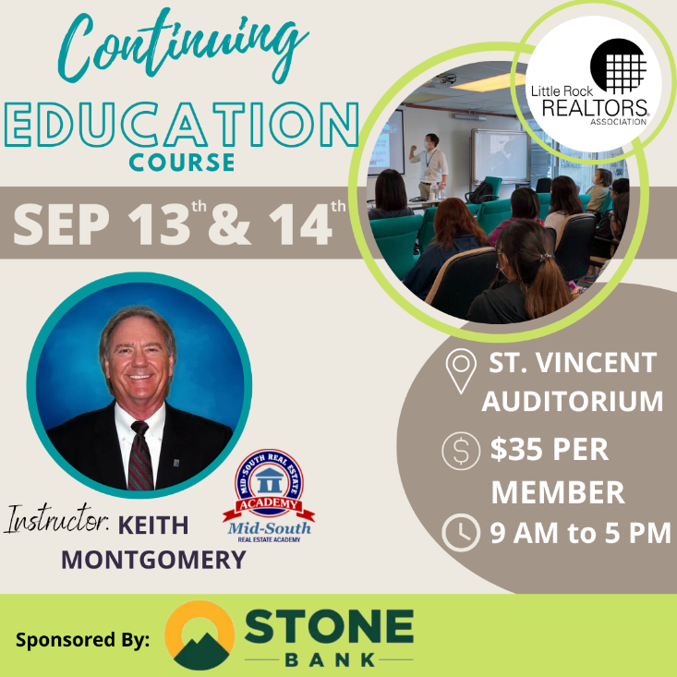

2023 ORIENTATION
Next Orientation
If you have missed your scheduled Orientation date or missed being inducted in the past year, please call our office at 501-225-1987 so you can complete the process and not have to start the process all over.
Please note that you have two opportunities to attend an orientation from the time that you sign up for membership. If you miss those two opportunities you will be placed on inactive status and your CARMLS access will be inactivated until you have completed orientation. You will be notified by email when you become eligible to attend New Member Orientation. Our next Orientation will be in person, at our office on March 9th.

AFFILIATE SPONSORSHIP OPPORTUNITIES
LRRA is looking for sponsors for the 2023 year. Please contact Libby for sponsorship opportunities. We try not to have sponsors from the same industry, but we cannot guarantee it won’t happen...i.e. 2 mortgage companies, 2 inspectors, etc. Please email Libby@LRRA.com and cc Jesse@LRRA.com to let us know you want to sponsor and we will let you know if the sponsorship is open.
We have general Meetings, Orientations, Lunch and Learns, REALTOR® Awards of Distinction, Broker meeting, and many more opportunities to sponsor in 2023. Thank you for all you do to support the Little Rock REALTORS® Association and our members!
To our LRRA members: Please take note of the Affiliate members who sponsor our events. They are investing in you and we hope you will take note and invest in them in return by giving them your business.

Legislative Affairs
August Newsletter

Little Rock Mayor Frank Scott has now held a handful of community meetings to garner public feedback on his proposed sales tax increase. There are several “pillars of focus,” including public safety, public infrastructure, parks and recreation, and port and economic development. Specifics include a proposed indoor/outdoor sports complex at War Memorial, street and sidewalk improvements ($115 million), Zoo enhancements ($40 million), and additional police and fire vehicles and equipment ($65 million).

To put the tax on the November ballot for voters to consider, the Board of Directors must approve the measure and send it to the clerk by September 5. Otherwise, the next opportunity for the ballot will be March.

The Little Rock City Board recently approved the first Short-Term Rental (STR) application under the new guidelines. A property in the Birchwood neighborhood will be allowed to house renters for up to 14 days. Staff had recommended against approval of the application, saying it would “be out of character with the overall area…” The total number of STRs able to operate in the city at one time is capped at 500 under the new ordinance.

Meanwhile, two candidates have filed to run for the Zone 5 position on the Little Rock School Board. Current board member Ali Noland has said she will not run for re-election. Anna Strong and Donnally Davis filed ahead of the recent deadline. Strong, 41, is the executive director of the Arkansas Chapter of the American Academy of Pediatrics and a parent of LRSD students. She has an undergraduate degree in Math and Physics from Hendrix and a double master’s degree from the Clinton School of Public Service and UAMS College of Public Health. Davis is marketing director for her family business, the Ouachita Roaster, Eatery and Brewery. She is married to lobbyist J.R. Davis. She has a degree in early childhood education from Arkansas Tech University and worked as a classroom teacher for six years before doing communications work for the state of Arkansas.

Incumbent Vicki Hatter filed for re-election to the Zone 6 position.

NEW MEMBERS
Brokers, we work very, very hard to get your agents onboarded as fast as we can, however, this time of year takes longer, because of the high instances of transfers, new members and new offices at this time. Please make sure to let your new agents know that joining, transferring, or changing information takes longer than normal at this time. Please make sure they know it may take up to 24 hours to get all the information needed and uploaded before they can expect to have access to the MLS or forms.

TRANSFERS
If you are planning on transferring, please remember that it may take a few days longer than usual because the AREC is very busy at this time. If transferring offices, please submit the LRRA office transfer form and $35 to the Little Rock REALTORS® Association once you’ve transferred with the AREC. Please remember anything else may take longer than usual and everyone should expect it to take at least 24 hours to get you onboarded.

LRRA EDUCATION ROOM RENTAL
LRRA rents its Education Room and Board Room out to interested groups in need of a classroom or lecture space. The Education Room is perfect for meeting space and seats up to 55. Our Education Room comes equipped with a large white board, a projector, overhead projector, podium, screen, 55 “television and Internet connections for all your connection needs. Our building is also equipped with Wi-Fi. Please call Libby at 225-1987 for competitive rental rates.

Financial Wellness Webinars
The NAR is offering Financial Wellness Webinars which are designed to help REALTORS® understand financial topics on a deeper level. No matter the career stage or level of financial planning, these webinars are helpful and informative to all members. Go to their website to learn more and get signed up.
CODE OF ETHICS vs. CE
The Code of Ethics….is a course each NAR-ARA-LRRA member takes upon joining the association and every three years after, for the duration of your membership. The Code of Ethics is what distinguishes our members from being just a licensee. Passing the Code of Ethics is what distinguishes a REALTOR® from a real estate agent. In order to reaffirm your commitment to being a REALTOR® you must retake the course every three years. It is on line and free. The current cycle ends December 31st, 2021.
Your Code of Ethics is not necessarily a continuing education class. It can be, but is not CE unless clearly stated by the instructor.
Each time you take Code of Ethics courses, either on line or through a licensed instructor, it is the agent’s responsibility to send a copy to their local board for coding into the NRDS system.
Code of Ethics does not go to the Arkansas Real Estate Commission…..it goes to your local board for entry into the NRDS database.
CE is what is required by the Arkansas Real Estate Commission for you to maintain a license to practice real estate in Arkansas.

NAR CODE OF ETHICS REQUIREMENT
We want to make you aware of a new NAR rule concerning Code of Ethics. Please make sure your agents are aware of this new NAR requirement.
If your agent believes he/she has taken it then they will need to provide us with a copy of their certificate showing the course included NAR required Code of Ethics.
We do not necessarily get notice that the agent completed the requirement when the educator turns the course list into the Commission. It is up to each agent to provide LRRA with a copy of their certificate to show they have completed the 2.5 required hours.
Noncompliance will force us to inactivate your membership. We do not want to do that! Please make sure you take the course at least 1 time every 3 years.

NEED YOUR NRDS NUMBER?
Do you need your NRDS number to pay dues, make a reservation, log on to REALTOR®.org?
If you joined the REALTORS® association through LRRA, your NRDS number will begin with 1280.
If you don’t have it here are some simple ways to find it:
- Look at the white address label on the cover of YOUR REALTOR® magazine . Your NRDS number will be there.
- Check last year’s billing invoice in your Brokers administrative office, it is listed on each billing invoice.
- Once you have it, write it on the back of your pocket card for safe keeping.

REALTOR® TEAM STORE- LRRA DISCOUNT FOR MEMBERS ONLY
Want to order REALTOR® merchandise and receive a discount?
Well now you can! Go to the address listed below!
LRRArealtorteamstore.com
Buy REALTOR® logo merchandise and save 5% using your Little Rock REALTORS® Association discount code.
Enter LRRA under the area marked “Discount Coupon” during checkout at step 2 of 4.

WELCOME TO LRRA OUR NEWEST REALTOR MEMBERS
Realtors:

Sara Sullivan | Keller Williams Realty LR
Michael Gabriel Bonsell | Keller Williams Realty LR
Shelly York | Coldwell Banker RPM Group-WLR
Angela McCloyen-Rogers | COCHRAN & DAVIS INV RLTY
Spencer Davis | Pinnacle Realty Advisors
Michael Ragsdale | United Real Estate-Central Ark
Trakenya Dobbins | Eagle Branch Properties and Management
Anna Toepfer | MIDSOUTH Realty
Rodney Cummings | Keller Williams Realty LR
Jada Jamerson | Resource Realty
Emily Goodhart | Arkansas Property Management and RE
Angela Frierson | Unlimited Properties Realty
Joedon Amara-Bangali | Brokers Guild
Margaret Chapple | Dawn Realty & Associates
Cierra Tyler | The Midas Real Estate Group
Lauren Henrich | Engel & Volkers Little Rock
Tomia Lenee Sutton | Start to Finish Realty
Kristen Kyle | Signature Properties

WELCOME TO LRRA OUR NEWEST REALTOR MEMBERS!

LRRA Mission Statement: Little Rock REALTORS® Association provides its membership the opportunity to enhance REALTOR® performance through education, technology and integrity.
LRRA Vision Statement: Little Rock REALTORS® Association strives to serve as a voice for local REALTORS®, encourage a high level of ethics, education and professionalism among its members and to advocate on behalf of the profession.
LRRA Core Values: Education, Professionalism, Support of Members, Value to the Membership, Integrity, Property Rights, Voice to lobby and promote, Serve and Support our members and community, Advocacy and Ethics.
Melissa Glidden – Capital Sotheby’s International

LITTLE ROCK REALTORS® ASSOCIATION, INC.

2023 OFFICERS AND DIRECTORS

OFFICERS

President
-

Fletcher Hanson
-

Moses Tucker Partners

President Elect
-
Matty Ross
-
-The Charlotte John Company

Treasurer
-

Jon Kennon
-
iRealty Arkansas

Secretary
-
Mitsy Tharp
-
Signature Properties

Past President
-
April Findlay
-
-The Charlotte John Company

DIRECTORS

Ross McCain – The McCain Company
-

John Selva
-
Engel & Volkers
-

Kaye Chambers
-
-REMAX Elite

Jennif
er Kronenberger
-
-JK Real Estate

Patrick McKay
-
The Property Group

Stacy Hamilton
-
Coldwell Banker RPM Group - WLR

Conley Jones
-
-The Janet Jones Company

-

Whitney McLellan

-McLellan & Associates Real Estate

Kathy Patton

-Cry-Leike REALTORS – Kanis Branch

